

**Information Leaflet**

**Screening Clinic**

It is natural to feel apprehensive before attending your appointment we hope this leaflet will explain what to expect.

**What to expect at your appointment?**

This appointment is for you and your partner (if you have one), it is very important that your partner (if you have one) attends this appointment so you are both aware of the tests that are required and so a medical history can be obtained from you both.

The appointment may last up to 90 minutes.

We are a teaching hospital and on occasion we may have trainee medical and clinical staff working within our qualified team. We will always check this is okay with you prior to starting your consultation.

**Be prepared to answer questions**

In order to provide an in-depth medical history, it’s important to be open and honest even though you may feel a little embarrassed.

* Please bring a list of medication that you are both taking (if applicable)
* We will need to ask you how long you have been trying to get pregnant, how often you have sexual intercourse and if there are any difficulties.
* We need to ask If you have had any previous pregnancies (including miscarriages and termination of pregnancy)
* We will ask about your past medical history
* We will ask about your lifestyle including smoking, recreational drugs and alcohol intake.

**Please ensure you have added your partner details (if you have one) via the QR that was sent on your appointment letter. We require this information 7 days prior to you attending. If we don’t receive this information in advance, it will cause delays to your appointment time whilst you complete the forms in the waiting area.**

**Common Fertility Tests/ Screening**

During your appointment you will see one of our Sonographers/ Nurse Sonographers and a Transvaginal Ultrasound Scan will be performed.

This is where an internal scan probe is inserted into the vagina. Some people may find this procedure a little uncomfortable, but this gives a very clear view of the womb and ovaries. An Antral-Follicle Count will be performed, Antral follicles are ovarian follicles that still contain immature eggs. If the ultrasound reveals very few antral follicles, it is an indicator of fewer eggs remaining. The antral follicles reduce with an increase in a woman’s age.

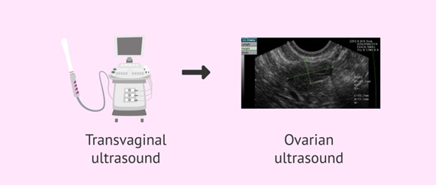The sonographer will write a report about the findings which will be discussed with you at your **next** appointment.

If you feel you are unable to tolerate a transvaginal scan or have a medical reason that means this would be difficult, please attend the clinic with a full bladder and inform a nurse on arrival.

During your appointment you will also see another member of the team who will organise/ obtain further tests, including blood tests. They will also check your BMI (this is a value derived from ratio of height and weight).

**Tests for Woman.**

**Rubella immunity screening-** this is a blood test to ensure you have immunity to Rubella (German Measles), Rubella can be very serious if a pregnant woman catches it in the early stages of pregnancy.

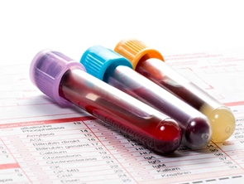**Anti-Mullerian Hormone (AMH)** - is produced by small follicles (pouches which contain the eggs) growing in the ovary. It can be measured in a blood test. The level of AMH reflects how many follicles are growing, which gives an indication of how many eggs are present in the ovary. The number of eggs present in the ovary declines as we age, until the menopause, when the supply runs out. The more follicles that are growing, the higher the level of AMH in the blood. This test is interpreted alongside the Antral Follicle Count scan.

**Progesterone** - this is a blood test to check if you are ovulating.

**Chlamydia Screening-** Chlamydia is a sexually transmitted infection that can affect fertility; a urine sample is obtained to detect this.

**Tests for Men**

**Semen Analysis-** It is important that a semen analysis (within the last year) has been performed. This is to check if there are any problems with your sperm. An appointment will be organised so that the sample can either be produced at home and brought to the andrology section of the unit or produced on site.

A further information leaflet will be given about this.

**Blood tests**- Occasionally hormone blood tests may need to be performed.

**What your appointment is not**

* This appointment is not to check about your eligibility for NHS fertility treatment. That will be checked by a separate office within the hospital based on your CCG and individual circumstances.
* The appointment is not to give results of any previous investigations, it is a screening clinic to instigate investigations.

**Next Steps**

After your appointment a follow- up appointment will be made with a clinician to discuss your results of the tests performed and next steps. This is usually via a telephone consultation.

Occasionally (depending on your individual history) a test to check the patency of fallopian tubes is made for the woman.

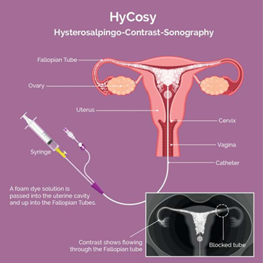Hysterosalpingo-contrast-sonography test (a Hycosy test) is arranged. This is a procedure using advanced ultrasound to test for common symptoms such as blocked fallopian tubes. A contrast agent is passed into the uterus via a fine catheter and the sonographer tracks this agent using ultrasound. If this test needs to be performed it will be carried out prior to your follow up appointment so that all your results can be given altogether.

**Lifestyle**

**Stop Smoking-** Smoking has been linked to infertility and early menopause in women and has been shown to reduce sperm quality in men. It is also a factor in premature or low birth-weight babies. It may also affect your eligibility for NHS funding for fertility treatment.

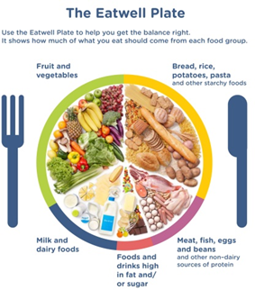

**A balanced healthy diet** is important for your general health as well as fertility. It’s important to aim for a BMI less than 30 (more than 30 may affect your NHS funding eligibility criteria)

[www.nhs.uk/livewell/goodfood/pages/goodfoodhome](http://www.nhs.uk/livewell/goodfood/pages/goodfoodhome)



Folic Acid is important to help your unborn baby's brain, skull and spinal cord develop properly to avoid development problems (called neural tube defects) such as spina bifida. Women should take this before getting pregnant and continue up to your 12th week of pregnancy. You are also advised to take Vitamin D daily. [www.nhs.uk/medicines/folic-acid/](http://www.nhs.uk/medicines/folic-acid/)

**Alcohol-** the safest approach is not to drink alcohol at all to keep risks to your baby to a minimum. Drinking too much alcohol can also affect the quality of sperm (UK Chief Medical Officers recommend adults should drink no more than 14 units of alcohol a week, which should be spread evenly over 3 days or more)

**Useful Info**

[www.nhs.uk](http://www.nhs.uk)

[www.hfea.gov.uk](http://www.hfea.gov.uk)

**This leaflet can be made available in different formats on request. If you would like to make any suggestions or comments about the content of this leaflet, then please contact the Patient Experience Team on 0151 702 4353 or by email at pals@lwh.nhs.uk**

Liverpool Women’s NHS Foundation Trust

Crown Street

Liverpool

L8 7SS

Tel: 0151 708 9988

© Liverpool Women’s NHS Foundation Trust