Diagnostic Andrology User Manual

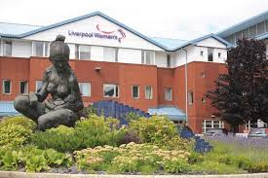  Liverpool Women’s Hospital | 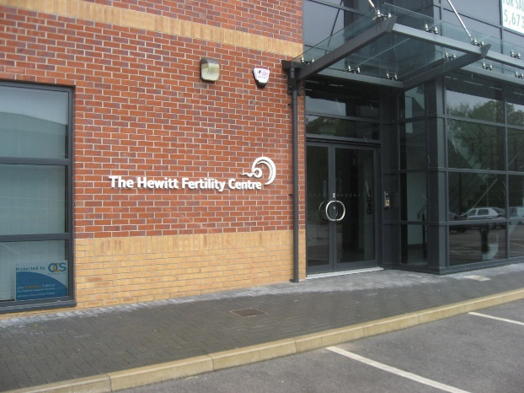  Hewitt Fertility Centre Knutsford
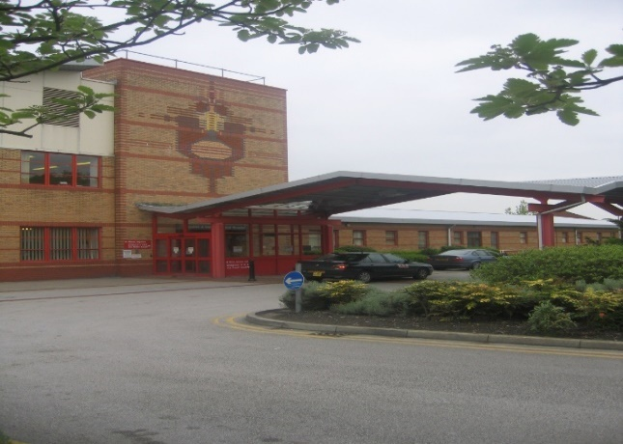  Ormskirk District General Hospital | 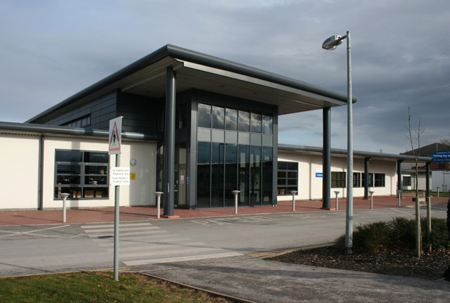  Leighton Hospital


CONTENTS

1 INTRODUCTION 3
2 CONTACT DETAILS 3
3 LOCATIONs 3
4 OPENING TIMES 4
5 ROUTINE TESTS PROVIDED 4
5.1 Other tests 4
6 PROTECTION OF PATIENT INFORMATION 5
7 HOW TO REQUEST A SEMEN ANALYSIS 5
7.1 External referrals 5
7.1.1 Receipt of referral 6
7.2 Internal referrals 6
8 INSTRUCTIONS FOR PRODUCTION OF SEMEN samples 7
9 INSTRUCTIONS FOR THE TRANSPORTATION OF SEMEN SAMPLES 7
10 Acceptance/ REJection criteria 7
11 Diagnostic semen analysis 7
11.1 Lower fifth percentile values 8
11.2 Interpretive comments and terminology 8
11.3 Hewitt Fertility Centre suggested clinical decision tree 9
11.3.1 Referral on NHS E-Referral to the Andrology Clinic 10
11.3.2 Referral on NHS E-Referral to the Fertility Infertility Nurse Gynaecology 10
11.4 Probability of undetected spermatozoa 10
12 vasectomy semen analysis 10
12.1 Interpretive comments 11
12.2 Hewitt Fertility Centre suggested clinical decision tree 11
13 REPORTING OF RESULTs 12
13.1 TURNAROUND TIME 12
14 advice, comments, feedback and complaints 12
14.1 Patients 12
14.2 Referrers 12
14.3 Complaints 13
15 Measurement of Uncertainty 13
16 Procedure ‘flow-diagram’ with approximate timescales 13
17 Appendix 13

INTRODUCTION

This manual describes the policies, procedures and repertoire of:
- The Andrology Laboratory, The Hewitt Fertility Centre at Liverpool Women’s Hospital
- The Andrology Laboratory, at the Hewitt Fertility Centre, Knutsford
- The Seminology Laboratory, Antenatal and Gynaecology Department at Ormskirk
- The Andrology Laboratory, situated within Ward 25, at Leighton Hospital

These departments are manned by the dedicated staff of The Liverpool Women’s Hospital NHS Foundation Trust. We work towards the standards outlined by the WHO Laboratory manual for The Examination and Processing of Human Semen, 2021, Laboratory Guidelines for Post Vasectomy Analysis 2016, ISO16190:2003 Medical Laboratories Requirement for Safety and ISO 15189:2022 Medical laboratories – Requirements for Quality and Competence.

CONTACT DETAILS

The contact details for each site are as follows:

The Lewis-Jones Andrology Department
Hewitt Fertility Centre
Liverpool Women's Hospital
Crown Street
Liverpool
L8 7SS
Tel: 0151 702 4214
Email: lwft.andrologylab@nhs.net

The Hewitt Fertility Centre
4 The Pavillions,
Knutsford Business Park,
Mobberley Road,
Knutsford ,
WA16 8ZR.
Tel: 01565 653287
Email: lwft.andrologylab@nhs.net
The Seminology Laboratory
Gynae and Maternity Outpatients
Ormskirk District General Hospital
Wigan Road
Ormskirk
L39 2AZ
Tel: 0151 702 4214
Email: lwft.andrologylab@nhs.net

Andrology Laboratory
Ward 25
Leighton Hospital
Middlewich Road
Crewe
CW1 4QJ
Tel: 01270 612212
Email: tmc-tr.semen.analysis@nhs.net

LOCATIONs

- Liverpool site: The Lewis-Jones Andrology Laboratory is located on the 2nd floor of the Liverpool Women’s Hospital. From the main entrance of the hospital proceed to the left and using lifts 3 & 4 go to the 2nd floor. On exiting the lift turn to the right and the Andrology Laboratory entrance is located on the left.

- Knutsford site: The Andrology Laboratory is situated on the ground floor of the Hewitt Fertility Centre, Knutsford. Patients are to arrive at the reception of the department where they will be directed by staff from there.

- Ormskirk Site: The Seminology Laboratory is situated on the ground floor of Ormskirk District General Hospital. From the main entrance of the hospital, proceed down the main trust corridor and enter the Maternity and Gynaecology Outpatients department on the right, approximately 2/3 of the way down the corridor. The laboratory is located on your first right. Two signposts reading ‘Seminology laboratory’ and can be found on the main trust corridor.

- Leighton Site: The Andrology Laboratory is situated on the 2nd floor (Ward 25) of Leighton Hospital in the Pink Zone. From the Maternity and Women’s services entrance, proceed down the corridor and take the stairs/lift on the left-hand side to the 2nd floor.

OPENING TIMES

- The Lewis-Jones Andrology Laboratory at Liverpool Women’s hospital is open 08:30 – 16:30 Monday to Friday (except bank holidays). There is a telephone service and answer-machine in operation when the laboratory is closed. Patients and/or referring clinicians can contact the laboratory staff with any queries, or to reschedule and cancel appointments. There is no out-of-hours service unless exceptional circumstances prevail.

- The Andrology Laboratory at Knutsford is open 08.30 – 15.00 Monday to Friday (except bank holidays). There is a telephone service and answer-machine in operation when the laboratory is closed. Patients and/or referring clinicians can contact the laboratory staff with any queries, or to reschedule and cancel appointments. There is no out-of-hours service unless exceptional circumstances prevail.

- The Seminology Laboratory at Ormskirk District General Hospital is open one Monday every 3 weeks, 08:30 – 15:00 (except bank holidays). When the Ormskirk laboratory is closed, there is a telephone service and answer-machine in operation at the Liverpool Women’s Hospital. Patients and/or referring clinicians can contact the laboratory staff with any queries, or to reschedule and cancel appointments. There is no out-of-hours service.

- The Andrology Laboratory at Leighton Hospital is open 09:00 – 14:00 two Thursdays a month, and 09:00 – 14:00 on Fridays. There is a telephone service and answer-machine in operation when the laboratory is closed. This service can be used regarding appointments which need to be cancelled or changed. There is no out-of-hours service.

ROUTINE TESTS PROVIDED

The Andrology Laboratory provides a range of Andrology tests and follows recommendations made by the World Health Organisation (WHO Laboratory manual for The Examination and Processing of Human Semen, 2021), Laboratory Guidelines for Post Vasectomy Analysis 2016 and The Association of Reproductive and Clinical Scientists (ARCS).

Routine tests include:
- Diagnostic fertility semen analysis (including assessment of retrograde ejaculation)
- Post-vasectomy semen analysis

Other services provided by the Andrology laboratory include:
- Sperm cryopreservation
- Sperm DNA fragmentation for HFC patients on a self-funded basis only
- Microbial Culture & Sensitivity

Other tests

If anything other than a semen analysis is required, the clinician should contact the laboratory on the appropriate contact number (section 2), where further information will be given upon request.

NB. The Ormskirk and Leighton Hospital Andrology Services can provide semen analysis testing only.

NB. Referrals for fertility investigations by a fertility specialist (either as a couple or separately) are processed separate to the Andrology lab and must be referred via the E-referral, or letter addressed to the Hewitt Fertility Centre.

PROTECTION OF PATIENT INFORMATION

The information that you give to us regarding your patients is protected by Liverpool Women’s NHS Foundation Trust policies. The following link will direct you to more information if required: https://www.liverpoolwomens.nhs.uk/about-us/our-aims-vision-values/

HOW TO REQUEST A SEMEN ANALYSIS

External referrals

Semen analysis appointments for the Liverpool, Ormskirk and Knutsford sites are made through the NHS e-Referral Service (e-RS) via a directly bookable service (DBS). The services are published on the Directory of Services (DOS), Secondary Care Menu. NB. Leighton appointments are not currently available on e-referral. Therefore, clinicians should instead email a ‘Semen Analysis Request Form’ to tmc-tr.semen.analysis@nhs.net.

The below details our available services on e-referral.

Service names:
- Diagnostic semen analysis at the Hewitt Fertility Centre, Liverpool Women’s Hospital FT.REP (Service ID 7981601)
- Diagnostic semen analysis at the Hewitt Fertility Centre, Knutsford (service provided by LWH) REP (Service ID 7981706)
- Diagnostic semen analysis at the Seminology lab, Ormskirk Hospital, (service provided by LWH) REP (Service ID 7982143)
- Post Vasectomy Semen Analysis at the Hewitt Fertility Centre, Liverpool Women’s Hospital F.T.REP (Service ID 7984416)
- Post Vasectomy Semen Analysis at the Hewitt Fertility Centre, Knutsford (service provided by LWH) RE (Service ID 7984431)
- Post Vasectomy Semen Analysis at the Seminology Lab, Ormskirk Hospital (service provided by LWH) REP (Service ID 7984430)
Service locations:
- LIVERPOOL WOMENS HOSPITAL (Liverpool)
- HEWITT FERTILITY CENTRE KNUTSFORD (Knutsford)
- ORMSKIRK DGH (Ormskirk)
Specialty:
- Urology
Appointment type:
- First Outpatient
Clinic types:
- Male infertility
Clinical terms:
- Clinical findings (Fertility problem, Low sperm count in partner, Male infertility, Male reproductive finding, Sperm finding)
- Situations (Reversal vasectomy requested)
- Procedures (Infertility study, Referral to fertility clinic, Referral to male urology clinic, Referral to urology service)

There are two ways that appointments can be made via the directly bookable service:

- A patient appointment date and time is made whilst in the practice with the referring clinician.
- The patient is given the necessary information to enable them to choose their appointment date and time at their own convenience either
  - via the internet
  - or through the telephone appointments line (TAL).

NB. Patients will need to provide their booking reference number and password/access code when booking appointments.

Appointments are made subject to an eligibility check and may be cancelled. The patient will be contacted if this is the case. There is rolling block on available appointments to allow for a semen analysis pack to be posted to the patient.

If e-referral is not available, clinicians should be email lwft.andrologylab@nhs.net or contact the lab on 0151 702 4214 for further information on how to proceed.

Receipt of referral

On receipt of a referral, the Andrology Laboratory, or Leighton administrative staff, will send the patient a pack via post containing:

- A covering letter
- A semen collection pot and pathology bag
- And a ‘Record Of Semen Production And Instructions’ form including the date and time of their appointment, and a link to a patient information leaflet.

Patients can rearrange the date and time of their appointment via e-Referral or by contacting the laboratory on the number provided in the patient pack. Appointments can be changed to other sites if requested.

Internal referrals

Appointments can be made by any appropriately trained staff member by directly booking a specific appointment date and time on the IDEAS fertility database. The staff member then issues the patient with a pack (outlined in 7.1.1).

Non-trained members of staff, or those without access to the IDEAS fertility database can issue the patient with a pack and complete SCI-AND-FORM-30. SCI-AND-FORM-30 is used solely by the gynaecology outpatients department (GOPD) at The Liverpool Hospital where specific appointment slots on IDEAS are held for GOPD patients. A member of the Andrology team will collect this form once per week and book onto the IDEAS fertility database themselves.

INSTRUCTIONS FOR PRODUCTION OF SEMEN samples

Instructions for the production of semen samples are detailed in the ‘Record of Semen Production and Instructions’ form, contained in the patient pack. Patients are advised to carefully follow the instructions on this form in order to optimise the semen sample that they produce. The instructions should be read in advance of the appointment due to abstinence requirements for this test. The patient can request these instructions verbally or in another language by contacting us on the appropriate phone number listed in section 2.

Patients should be advised to only use the collection vessel provided by the laboratory as these will have been toxicity tested on a batch-by-batch basis, the sterility of the sample container can be assured and a more accurate calculation of seminal volume can be made. The pot must not be exposed to extremes of temperature either before or after sample production. If there is concern, the patient should speak to a member of staff.

Patients should produce their sample by masturbation only, and not using condoms, lubricant or coitus interruptus. If they are unable to ejaculate by masturbation, special condoms for use at home may be provided in exceptional circumstances. However, the entire ejaculate will not be available for examination, and the specimen is likely to be contaminated by contact with the skin of the penis and to some extent also vaginal fluid and cells on the outside of the condom.

INSTRUCTIONS FOR THE TRANSPORTATION OF SEMEN SAMPLES

Samples can be produced at home or at the facilities available at the clinic. If producing at home the sample pot should be kept close to the body under clothes during transportation (for example, in a pocket) and delivered to the laboratory preferably within 30 minutes after collection and at least no longer than 50 minutes after collection. If sample delivery does not occur within this specified time frame, the patient may need to repeat this process. If preferable, the patient’s partner can deliver the sample on the patient’s behalf.

Acceptance/ REJection criteria

Any patients who attend the laboratory without a prior referral will not be accepted under any circumstances

SCI-AND-SOP-27 outlines the laboratories sample acceptance and rejection criteria in circumstances including if:

- The sample pot is not clearly labelled
- The sample has produced at home into a non-laboratory issued container
- The sample has leaked into the specimen bag
- The patient has the incorrect abstinence period
- The sample was delivered to the laboratory more than 50 minutes after production meaning it could not be analysed within 60 minutes of ejaculation
- The sample pot has been exposed to extremes of temperatures

In cases where the sample is accepted for analysis but there is any deviation away from normal semen parameters, which may have been caused by failure of the patient to follow the instructions provided, the report will indicate that a repeat analysis is suggested. It is up to the referring clinician to action a referral for this repeat analysis. It may be advised that the patient produces their repeat sample on site.

Diagnostic semen analysis

The following parameters are measured and included on the report. These parameters are closely linked with the analysis interval:

Parameter | Explanation
Appearance | The visual appearance of the ejaculate e.g normal, opaque etc.
Semen volume | The volume of the ejaculate (ml).
pH | The pH of the ejaculate is measured to assess the function of the seminal vesicles.
Viscosity | The consistency of the ejaculate e.g. viscous or non-viscous.
Presence of agglutination | An assessment of any motile sperm sticking to each other by their heads, tails or mid-pieces. The major type of agglutination (reflecting the degree and the site of attachment) is reported. Please see page 22 of the WHO 2021 manual for further information WHO laboratory manual for the examination and processing of human semen
Presence of round cells | The number of non-sperm cells in the ejaculate (NB. No differentiation is made between non-sperm round cells and leucocytes). Reported as an estimated number in millions of round cells per ml of ejaculate (NB. Action is taken only if the number of round cells is >5 M/ml).
Sperm concentration | The number of sperm per ml of ejaculate (millions/ml).
Total sperm number | The total number of sperm in the whole ejaculate (millions).
Sperm motility | The motility of sperm (at 37°C) expressed as the percentage of rapidly progressive, slowly progressive, non-progressive and immotile sperm
Sperm morphology | Percentage of sperm with ‘normal’ morphology.
Sperm vitality | The percentage of live sperm in the ejaculate. Only measured if sperm motility <10%.
The time to examination is included on the report and represents the period of time (in minutes) that macroscopic analysis of the semen sample began, following ejaculation.

Lower fifth percentile values

Data characterising the semen characteristics of a reference population (from men in couples whose partners had a time to pregnancy of 12 months or less) has been revised since the previous version of the WHO Manual in 2010, resulting in a change to the lower fifth percentile values (see Table below). It is important to note that these percentiles do not represent distinct limits between fertile and sub fertile men, so caution is needed to avoid over-interpretation.

Parameter | Lower fifth percentile value (WHO 2021)
Semen volume | 1.4ml
Progressive motility | 30 (%)
Sperm concentration | 16 (million per ml)
Total sperm number (this takes preference over sperm concentration) | 39 (million per ejaculate)
Sperm morphology | 4 (%)
Sperm vitality | 54 (%)

Interpretive comments and terminology

Each diagnostic semen analysis report will include a comment to aid interpretation of patient’s semen analysis results. These comments have been carried over from the 5th Edition of the WHO 2010 Manual for the Examination and Processing of Human Semen. Below is an example of some of the comments, and their interpretations, that may be included. This list is not exhaustive.

Comment | Interpretation
Normozoospermia | Total number of sperm, and percentages of progressively motile and morphologically normal sperm, equal to or above the lower fifth percentile values
Oligozoospermia | Total number of sperm below the lower fifth percentile values
Asthenozoospermia | Percentage of progressively motile sperm below the lower fifth percentile values
Teratozoospermia | Percentage of morphologically normal sperm below the lower fifth percentile values
Oligoasthenoteratozoospermia | Total number of sperm, and percentages of both progressively motile and morphologically normal sperm, below the lower fifth percentile values
Oligoasthenozoospermia | Total number of sperm, and percentage of progressively motile sperm below the lower fifth percentile values
Oligoteratozoospermia | Total number of sperm, and percentage of morphologically normal sperm, below the lower fifth percentile values
Asthenoteratozoospermia | Percentages of both progressively motile and morphologically normal sperm below the lower fifth percentile values
Necrozoospermia | Low percentage of live, and high percentage of immotile sperm in the ejaculate
Cryptozoospermia | Sperm absent from fresh preparations but observed in a centrifuged pellet

For more detailed interpretation and significance of results reported in a semen analysis, the Andrology Laboratory recommends referring to the WHO Laboratory Manual for The Examination and Processing of Human Semen, 2021 found at WHO laboratory manual for the examination and processing of human semen

Hewitt Fertility Centre suggested clinical decision tree

Recommendations:
If the first semen analysis shows a reduction in some semen parameters, this test should be repeated within an appropriate timescale as outlined below (A new referral is made on E-RS on each occasion).

Priority repeat – patient should have a repeat semen analysis immediately
Oligozoospermia with total sperm number <7M
Asthenozoospermia with progressive motility <10%
Teratozoospermia with 0 or 1% normal forms
Necrozoospermia
Cryptozoospermia
Apparent azoospermia (azoospermia is defined as the complete absence of spermatozoa in two separate centrifuged semen specimens.)

Non-priority repeat – patient should have a semen analysis in 3 months’ time
Oligozoospermia with total sperm number between 7M and 39M
Asthenozoospermia with progressive motility between 10% and 30%

If the second semen analysis is not improved, we suggest a referral of the patient be made to either the Andrology Clinic at the Liverpool Women’s Hospital, or as a couple via the Fertility Infertility Nurse Gynaecology Clinic. Referrals can be made by letter or on NHS E-referral (Choose and Book).

Referral on NHS E-Referral to the Andrology Clinic

Service Details Andrology - Male Infertility Clinic -Liverpool Women's Hospital Foundation Trust REP
Service ID 202666
Service Location LIVERPOOL WOMENS HOSPITAL
Gender treated Male
Specialty Urology
Clinic Type Male Infertility

NB. Searching via speciality and clinic type terms is the easiest way to find the service

Referral on NHS E-Referral to the Fertility Infertility Nurse Gynaecology

Service details Fertility Infertility Nurse Gynaecology - Liverpool Women's Hospital F.T.REP
Service ID 7687160
Gender treated Female
Service Location LIVERPOOL WOMENS HOSPITAL
Specialty Gynaecology
Clinic Type Infertility

NB. Searching via speciality and clinic type terms is the easiest way to find the service

Probability of undetected spermatozoa

According to the WHO Laboratory Manual for The Examination and Processing of Human Semen, 2021, if no spermatozoa are detected in wet preparations or following centrifugation, there is a low probability that spermatozoa may still exist in the ejaculate, depending on its total volume. For more details and probability estimation please refer to WHO laboratory manual for the examination and processing of human semen

vasectomy semen analysis

The Andrology Laboratory follows the 2016 Laboratory guidelines for post-vasectomy semen analysis: Association of Biomedical Andrologists, the British Andrology Society and the British Association of Urological Surgeons (P Hancock, BJ Woodward, A Muneer, JC Kirkman-Brown 2016, http://jcp.bmj.com/content/early/2016/04/15/jclinpath-2016-203731 ).

The following are also not suitable for deep chamber analysis.
- Non-homogenous samples,
- Samples with a high level of background debris
- High-viscosity samples which cannot fill the chamber completely

A post-vasectomy semen analysis will report any observations made on a large volume fixed depth slide. If motile sperm are present in the ejaculate, analysis will continue as a diagnostic semen analysis. If a low number of immotile sperm are observed, this number will be included in the report (in relation to 100,000 sperm per ml) to assist clinicians in giving ‘special clearance’. It is left to the clinical judgement of the referring clinician to decide whether this should be granted. Clinical advice can be provided on request (see Section 14 below).

In cases where the sample is not suitable for deep chamber analysis, including samples that are non-homogenous, samples that are highly viscous or have a high level of background debris, the coverslip and centrifugation method is used. This method will be stated on the report.

Interpretive comments

Below are some examples of comments that may be included on a post vasectomy semen analysis report. This list is not exhaustive.

Large volume fixed depth slide
No sperm seen on 25µl large volume deep chamber slide.
x non-motile sperm seen on 25µl large volume deep chamber slide. This equates to approx. x non-motile sperm per ml.
>200 non-motile sperm seen on 25µl large volume deep chamber slide. No motile sperm observed. Concentration then performed. Concentration of approximately x M/ml determined.

For more detailed interpretation and significance of results reported in a semen analysis, the Andrology Laboratory recommends referring to the 2016 Laboratory guidelines for post vasectomy semen analysis: Association of Biomedical Andrologists, the British Andrology Society and the British Association of Urological Surgeons. https://pubmed.ncbi.nlm.nih.gov/27083211/

Hewitt Fertility Centre suggested clinical decision tree

Interpretive comment | HFC suggestion
‘No sperm seen on 25µl large volume deep chamber slide. | Patient can be given clearance provided recommendation 5 of the 2016 Laboratory guidelines for post vasectomy semen analysis is met.  ‘Recommendation 5: Assessment of a single sample is acceptable to confirm vasectomy success if all recommendations and laboratory methodology are met and no sperm are observed. Clearance can then be given.’
‘x non-motile sperm seen on 25µl large volume deep chamber slide. This equates to approx. x non-motile sperm per ml. | Patient can be given clearance provided recommendation 6 of the 2016 Laboratory guidelines for post vasectomy semen analysis is met.  Recommendation 6: The level for special clearance should be <100,000/ml non-motile sperm. Special  clearance cannot be provided if any motile sperm are observed and should only be given after assessment of two samples in full accordance with these guidelines.
>200 non-motile sperm seen on 25µl large volume deep chamber slide. No motile sperm observed. Concentration then performed. Concentration of approximately x M/ml determined. | If concentration of x is >0.1, clearance is recommended not to be given as per 2016 Laboratory guidelines for post vasectomy semen analysis
Motile sperm observed in sample. | If any level of motile sperm is observed, clearance is recommended not to be given as per 2016 Laboratory guidelines for post vasectomy semen analysis

REPORTING OF RESULTs

IT IS THE RESPONSIBILITY OF THE SERVICE USER TO GIVE RESULTS TO PATIENTS. NOT THE LABORATORY. THE LABORATORY CAN OFF ADVICE TO THE CLINICIAN UPON REQUEST AS PER SECTION BELOW.

VERBAL RESULTS WILL NOT BE GIVEN OUT UNDER ANY CIRCUMSTANCES

A ‘Semen Analysis Report’ is generated by the Hewitt Fertility Centre’s ‘IDEAS’ database and returned by (in the following order of availability) Docman, email or post to the referring clinician.

TURNAROUND TIME

The Andrology Laboratory endeavours to return results within 10 working days of patient attendance.

advice, comments, feedback and complaints

A definition of the interpretive comments used on our Semen Analysis reports and a clinical decision tree which can be used to inform the next steps for diagnostic patients can be found in sections 11.4 and 12.2 of this document. However, clinical advice on any aspect of the diagnostic (or therapeutic) services provided by the Andrology Laboratory can be obtained from

Dr Rachel Gregoire, Scientific Director 0151 702 4173
Mr Richard Russell, Andrology Clinical Lead 0151 702 4215
The Andrology Laboratory 0151 702 4214

Or by e-mail enquiry to
rachel.gregoire@lwh.nhs.uk Scientific Director
stephanie.brooks@lwh.nhs.uk Quality Manager
Rebecca.lunt@lwh.nhs.uk Lead Clinical Embryologist
lwft@andrologylab@nhs.net General Enquiries

The Andrology Laboratory welcomes feedback from their patients and service users and shall be analysed and used to improve laboratory activities and services to users.

Patients

Patients attending for semen analysis appointments are sent a text message survey 24 hours after their appointment. Within the text message is a link to a feedback survey about their experience within the Andrology laboratory.

Referrers

Clinicians that refer into our services are encourgaed to provide feedback via email to the Quality Manager or general laboratory email address.

Complaints

Complaints should be directed to the Quality Manager or Scientific Director at the Hewitt Fertility Centre. This may be performed verbally via telephone or using the email addresses listed in section 14.

Measurement of Uncertainty

Clinicians and scientists are generally comfortable with the concept of uncertainty in relation to a blood test to determine for example a hormone level, but a semen analysis comprises a combination of different test results. As such it is important to consider the measurement of uncertainty in relation to semen analysis testing and the mechanisms that are in place to attempt to minimise uncertainty of measurement when assessing semen samples. Therefore, we have produced a document SCI-POL-1 ‘Uncertainty measurement in semen analysis – information for users’ that we ask that you read. It includes a section at the back with bullet points that you are asked to consider when interpreting the results that we provide.

Procedure ‘flow-diagram’ with approximate timescales

2 weeks
2 weeks

Appendix

Please see our website for access to our downloadable content (including referral form, uncertainty of measurement, and patient information leaflets)
For GPs and other Clinicians | The Hewitt Fertility Centre

